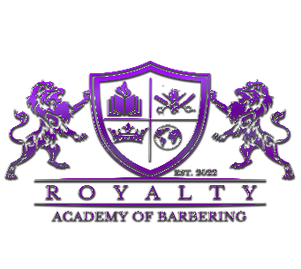
Royalty Academy of Barbering
2207 Clarksville Pike
Nashville, TN 37208
615-474-4163

ADMISSIONS APPLICATION / REGISTRATION

NAME ________________________________________ DATE __________________
PHONE NUMBER ( )__________________________ BIRTHDAY_______/________/________
ADDRESS: STREET______________________________________________________
CITY___________________________STATE__________ ZIP CODE: ________________

GENDER (M)______ (F)_______ ARE YOU A U.S. CITIZEN? (Y)_____(N)______ IF NOT, EXPLAIN.

SOCIAL SECURITY NUMBER ___ ___ ___ - ___ ___- ___ ___ ___
EMAIL ADDRESS: ____________________________________________
SOCIAL MEDIA: INSTAGRAM __________________________ FACEBOOK: _________________________
TIKTOK ________________________
EMERGENCY CONTACT:______________________________________RELATION:___________________
PHONE NUMBER: (____)____________________________

EDUCATION:
LAST GRADE COMPLETED:__________
LAST SCHOOL ATTENDED/ ATTENDING: ____________________________________________________________________________________
ADDRESS_________________________________ (CITY)______________________(STATE)___________
(COUNTRY)_____________________________ PHONE NUMBER:(______)______________________
LAST GRADE COMPLETED______________

RAOB ONLY OFFERS FULL-TIME ENROLLMENT!!!

APPLICATION / REGISTRATION FEE: $100.00
FORM OF PAYMENT:

DEBIT/ CREDIT ________ CASH ________ PAYPAL _______ VENMO _______

I,___________________________________, UNDERSTAND AND AGREE THAT ALL INFORMATION PROVIDED IS MY INFORMATION & LEGAL.

SIGNATURE____________________________________________ DATE __________________

